LINE CHART - STOCK PRICES OF STOCK A, STOCK B AND STOCK C
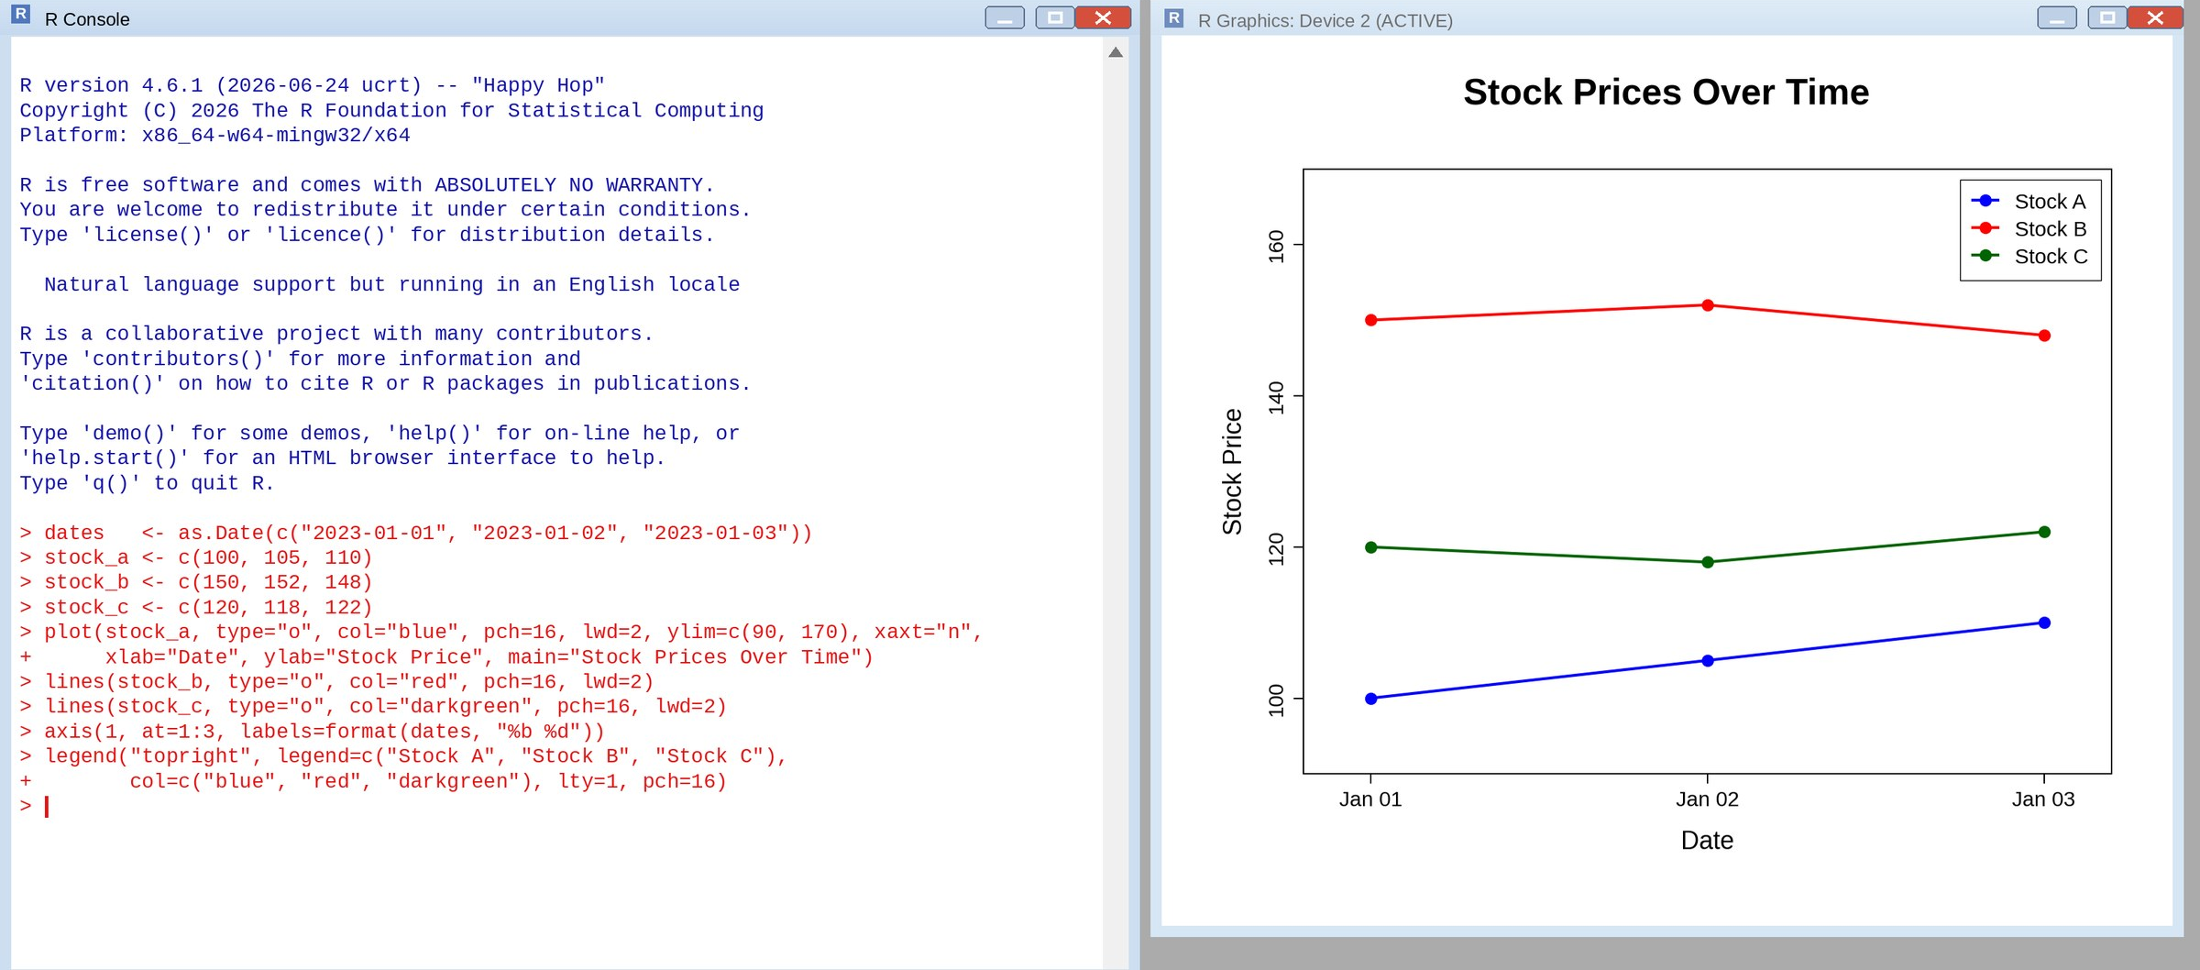
BAR CHART - STOCK A DAILY PERCENTAGE CHANGE
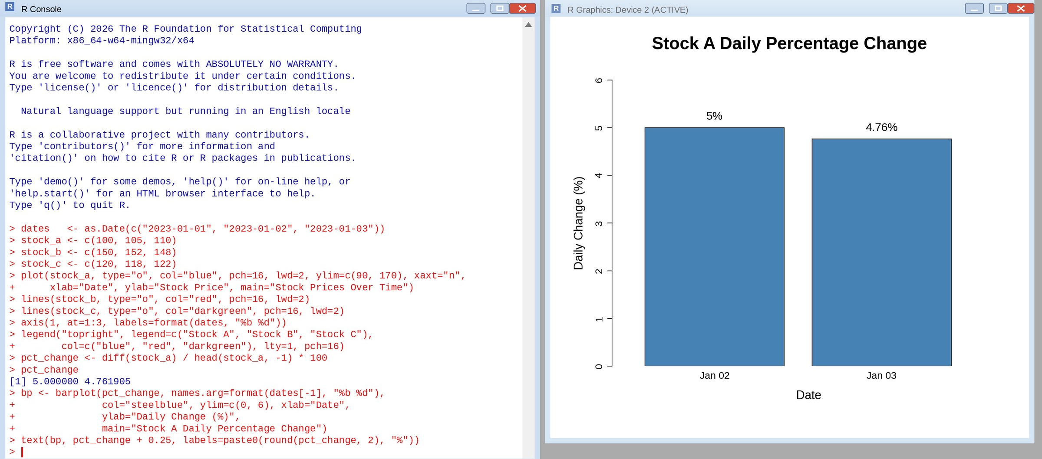
TABLE - STOCK PRICE DATA
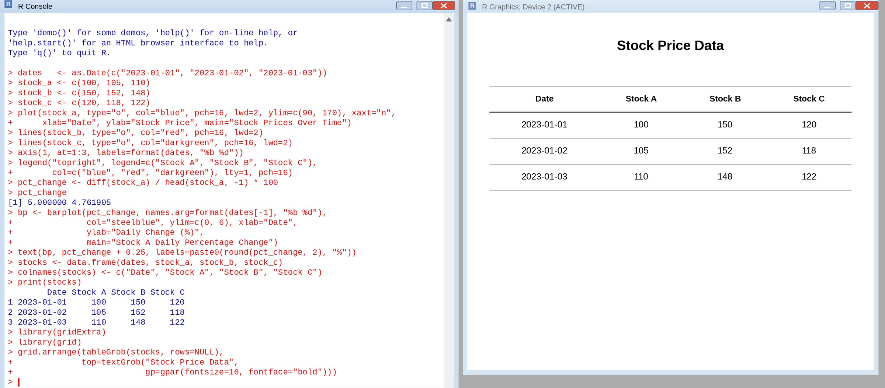
TABLEAU DASHBOARD - LINE CHART, BAR CHART AND TABLE
